Android Studio

1. Importing Project
   1. Open Android Studio
   2. In Android Studio, select import project and inside the directory of the project under demo choose build.gradle
2. Project Tab
   1. Click the 1: Project tab on the bar on the left side of the screen.
   2. Open app> java>hasler.fpaaapp>
      1. Lists
      2. Utils
         1. Configuration
            1. Location of zip files from github
         2. Driver
         3. Driver Fragment
         4. Generic Driver
         5. Target Program
         6. Utils
            1. debugLine
      3. Views
         1. DacAdcView
         2. GeneralView.java
            1. Copied over to OscopeView
         3. HomeView
         4. LpfView
         5. OscopeView
            1. Compile and program design onto FPAA

user input location of zip file used to program FPAA

the application downloads zip file and assigns it to a File object

will call targetProgram class to find the instruction file (targetlist.txt) inside the zip

based on targetlist.txt, OscopeView will send specific instructions to the FPAA

switchinfo and switch_program.elf are the files that are unique for each design, the switching includedby targetlist.txt

* + - * 1. Read wav files from zip files using zip File Location within application
        2. Play/Filter wav files and Plot data
      1. ReadWriteView
    1. ControllerActivity
       1. Add new fragment when creating new view
    2. NavigationDrawerFragment
  1. Open app>res>
     1. Layout
        1. Design the layout of different views
     2. Values
        1. Strings.xml
           1. Add section titles to the application

Device Info, DAC ADC Example, Oscope View

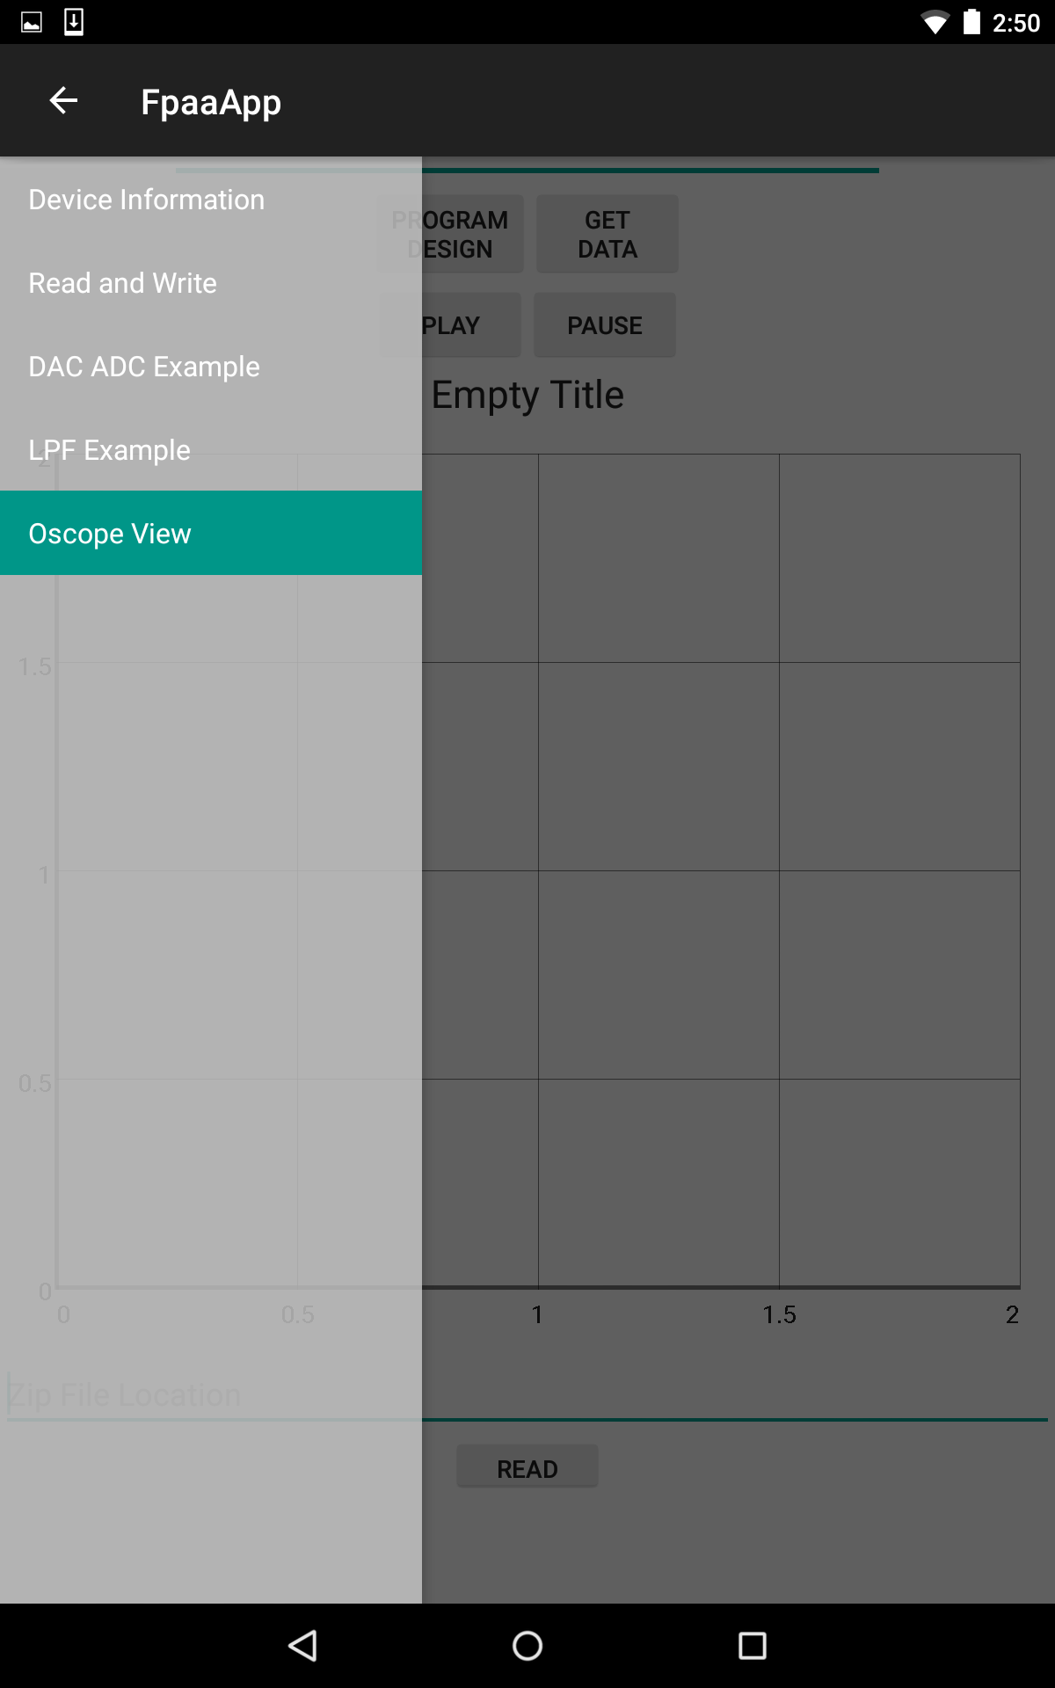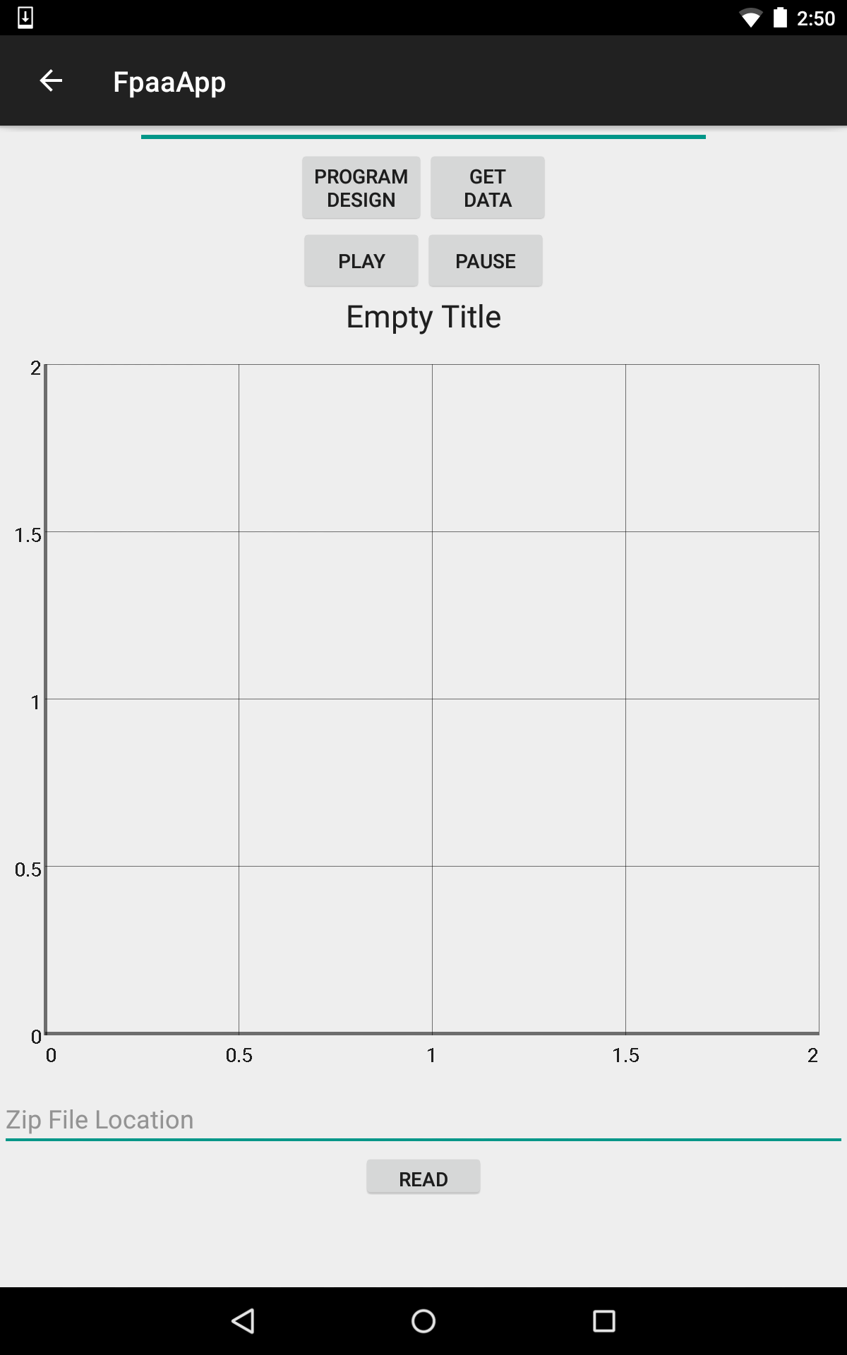

3. Note: rbrooksher3’s android repository on github.gatech.edu has the most updated application.